Supplementary material

Confidence limits for the averted infections ratio estimated via the counterfactual placebo incidence rate

Dunn DT, Stirrup OT, Glidden DV

Content

1. R code for profile likelihood confidence limits

2. Coverage of confidence limits based on delta method

3. Coverage of upper 5% confidence limit computed using the delta method (Figures)
4. Coverage probabilities for likelihood-based confidence limits with 40 expected counterfactual events per arm
5. Cumulative distribution function of the lower 5% confidence limit (true AIR=1, 40 expected counterfactual events per arm) (Figures)

1. R code for profile likelihood confidence limits

# specify the following
X_C<-33+0.5 # addition of 0.5 optional but recommended
X_E<-32+0.5 # ditto
F_C<-4896
F_E<-4926
LAMDA_P<-0.018 # counterfactual incidence
z<-qnorm(0.95) # level of confidence bound

# derived parameters
R_C <- X_C/F_C
R_E <- X_E/F_E
AIR <- (LAMDA_P-R_E)/(LAMDA_P-R_C)

PLL <- function(X,LAMDA_P,X_C,X_E,F_C,F_E,z) { # X is AIR
A<-X*(F_C+X*F_E)
B<-((F_C+X*F_E)*LAMDA_P*(X-1)+X*(X_E+X_C))
C<-X_C*LAMDA_P*(X-1)
R_C<-(B+sqrt(B^2-4*A*C))/(2*A)
R_E<-X*R_C-LAMDA_P*(X-1)
LL_MAX<-(-X_C)+X_C*log(X_C)-X_E+X_E*log(X_E)
LL<-(-F_C)*R_C+X_C*log(F_C*R_C) - F_E*R_E+X_E*log(F_E*R_E)
2*(LL_MAX-LL)-z^2
}

uniroot(PLL,c(0.001,AIR),LAMDA_P=LAMDA_P,X_C=X_C,X_E=X_E,F_C=F_C,F_E=F_E,z=z, tol=1.0e-6)$root # lower bound
uniroot(PLL,c(AIR,100),LAMDA_P=LAMDA_P,X_C=X_C,X_E=X_E,F_C=F_C,F_E=F_E,z=z, tol=1.0e-6)$root # upper bound

####
# following codes plots profile likelihood and Taylor series approximation

PLL_ed <- function(X,LAMDA_P,X_C,X_E,F_C,F_E) { # X is AIR
A<-X*(F_C+X*F_E)
B<-((F_C+X*F_E)*LAMDA_P*(X-1)+X*(X_E+X_C))
C<-X_C*LAMDA_P*(X-1)
R_C<-(B+sqrt(B^2-4*A*C))/(2*A)
R_E<-X*R_C-LAMDA_P*(X-1)
LL_MAX<--X_C+X_C*log(X_C)-X_E+X_E*log(X_E)
LL<--F_C*R_C+X_C*log(F_C*R_C) - F_E*R_E+X_E*log(F_E*R_E)
2*(LL_MAX-LL)
}

Taylor_approx_fun_logscale <- function(X,LAMDA_P,X_C,X_E,F_C,F_E, logscale_SE) { # X is AIR
AIR_max<- (X_E/F_E - LAMDA_P)/(X_C/F_C - LAMDA_P)
2*(log(dnorm(0))-log(dnorm((log(X)-log(AIR_max))/logscale_SE)))
}

logscale_SE<-sqrt( (R_E/F_E)/(LAMDA_P-R_E)^2 + (R_C/F_C)/(LAMDA_P-R_C)^2 )

library("ggplot2")

ggplot() + xlim(0.5, 1.5) + geom_function(fun = PLL, args=list(LAMDA_P=LAMDA_P,X_C=X_C,X_E=X_E,F_C=F_C,F_E=F_E,z=z))

ggplot() + xlim(0.5, 1.5) + geom_function(fun = PLL_ed, args=list(LAMDA_P=LAMDA_P,X_C=X_C,X_E=X_E,F_C=F_C,F_E=F_E)) +
geom_hline(yintercept=z^2, linetype="dashed") + theme_bw() +
xlab("AIR value") + ylab("Profile likelihood difference from max.") +
geom_function(fun = Taylor_approx_fun_logscale, args=list(LAMDA_P=LAMDA_P,X_C=X_C,X_E=X_E,F_C=F_C,F_E=F_E, logscale_SE=logscale_SE), linetype="dotted")

2. Coverage of confidence limits based on delta method

Values in the table show actual coverage relative to nominal coverage. For example, for AIR=0.5,θ_C=0.6,λ_P=40, the coverage for the lower 0.025 CL is 0.975-0.0215=0.9535.

+---------------------------------------------------------+
| | | | Lower CL | Upper CL |
| λ_P | θ_C | AIR | 0.025 | 0.05 | 0.95 | 0.975 |
|-----+-----+-----+---------+---------+---------+---------|
| 40 | .6 | .5 | -0.0215 | -0.0299 | +0.0500 | +0.0250 |
| 40 | .6 | .6 | -0.0118 | -0.0177 | +0.0500 | +0.0250 |
| 40 | .6 | .7 | -0.0015 | -0.0079 | +0.0500 | +0.0250 |
| 40 | .6 | .8 | +0.0065 | +0.0033 | +0.0474 | +0.0250 |
| 40 | .6 | .9 | +0.0140 | +0.0152 | +0.0366 | +0.0239 |
| 40 | .6 | 1 | +0.0184 | +0.0221 | +0.0221 | +0.0184 |
|-----+-----+-----+---------+---------+---------+---------|
| 40 | .7 | .5 | -0.0260 | -0.0344 | +0.0500 | +0.0250 |
| 40 | .7 | .6 | -0.0177 | -0.0207 | +0.0500 | +0.0250 |
| 40 | .7 | .7 | -0.0088 | -0.0144 | +0.0495 | +0.0250 |
| 40 | .7 | .8 | -0.0013 | -0.0038 | +0.0421 | +0.0249 |
| 40 | .7 | .9 | +0.0088 | +0.0076 | +0.0303 | +0.0216 |
| 40 | .7 | 1 | +0.0140 | +0.0175 | +0.0175 | +0.0140 |
|-----+-----+-----+---------+---------+---------+---------|
| 40 | .8 | .5 | -0.0284 | -0.0367 | +0.0500 | +0.0250 |
| 40 | .8 | .6 | -0.0226 | -0.0262 | +0.0500 | +0.0250 |
| 40 | .8 | .7 | -0.0157 | -0.0200 | +0.0475 | +0.0250 |
| 40 | .8 | .8 | -0.0069 | -0.0089 | +0.0374 | +0.0243 |
| 40 | .8 | .9 | +0.0038 | +0.0027 | +0.0274 | +0.0195 |
| 40 | .8 | 1 | +0.0130 | +0.0137 | +0.0137 | +0.0130 |
|-----+-----+-----+---------+---------+---------+---------|
| 40 | .9 | .5 | -0.0338 | -0.0379 | +0.0500 | +0.0250 |
| 40 | .9 | .6 | -0.0254 | -0.0331 | +0.0500 | +0.0250 |
| 40 | .9 | .7 | -0.0219 | -0.0248 | +0.0444 | +0.0250 |
| 40 | .9 | .8 | -0.0112 | -0.0207 | +0.0369 | +0.0238 |
| 40 | .9 | .9 | -0.0026 | -0.0097 | +0.0293 | +0.0205 |
| 40 | .9 | 1 | +0.0160 | +0.0142 | +0.0142 | +0.0160 |
|-----+-----+-----+---------+---------+---------+---------|
| 60 | .6 | .5 | -0.0236 | -0.0275 | +0.0500 | +0.0250 |
| 60 | .6 | .6 | -0.0138 | -0.0191 | +0.0500 | +0.0250 |
| 60 | .6 | .7 | -0.0058 | -0.0083 | +0.0482 | +0.0250 |
| 60 | .6 | .8 | +0.0015 | -0.0009 | +0.0374 | +0.0243 |
| 60 | .6 | .9 | +0.0080 | +0.0075 | +0.0250 | +0.0193 |
| 60 | .6 | 1 | +0.0133 | +0.0149 | +0.0149 | +0.0133 |
|-----+-----+-----+---------+---------+---------+---------|
| 60 | .7 | .5 | -0.0259 | -0.0277 | +0.0500 | +0.0250 |
| 60 | .7 | .6 | -0.0164 | -0.0202 | +0.0499 | +0.0250 |
| 60 | .7 | .7 | -0.0105 | -0.0124 | +0.0425 | +0.0250 |
| 60 | .7 | .8 | -0.0029 | -0.0062 | +0.0302 | +0.0222 |
| 60 | .7 | .9 | +0.0038 | +0.0035 | +0.0204 | +0.0161 |
| 60 | .7 | 1 | +0.0107 | +0.0118 | +0.0118 | +0.0107 |
|-----+-----+-----+---------+---------+---------+---------|
| 60 | .8 | .5 | -0.0275 | -0.0296 | +0.0500 | +0.0250 |
| 60 | .8 | .6 | -0.0188 | -0.0208 | +0.0481 | +0.0250 |
| 60 | .8 | .7 | -0.0154 | -0.0146 | +0.0379 | +0.0243 |
| 60 | .8 | .8 | -0.0074 | -0.0108 | +0.0283 | +0.0205 |
| 60 | .8 | .9 | +0.0001 | +0.0011 | +0.0195 | +0.0151 |
| 60 | .8 | 1 | +0.0089 | +0.0107 | +0.0107 | +0.0089 |
|-----+-----+-----+---------+---------+---------+---------|
| 60 | .9 | .5 | -0.0288 | -0.0333 | +0.0500 | +0.0250 |
| 60 | .9 | .6 | -0.0219 | -0.0292 | +0.0439 | +0.0250 |
| 60 | .9 | .7 | -0.0199 | -0.0212 | +0.0378 | +0.0232 |
| 60 | .9 | .8 | -0.0177 | -0.0174 | +0.0282 | +0.0202 |
| 60 | .9 | .9 | -0.0031 | -0.0049 | +0.0242 | +0.0171 |
| 60 | .9 | 1 | +0.0104 | +0.0130 | +0.0130 | +0.0104 |
|-----+-----+-----+---------+---------+---------+---------|
| 80 | .6 | .5 | -0.0211 | -0.0259 | +0.0500 | +0.0250 |
| 80 | .6 | .6 | -0.0129 | -0.0145 | +0.0497 | +0.0250 |
| 80 | .6 | .7 | -0.0062 | -0.0089 | +0.0421 | +0.0249 |
| 80 | .6 | .8 | +0.0001 | -0.0014 | +0.0295 | +0.0219 |
| 80 | .6 | .9 | +0.0052 | +0.0052 | +0.0197 | +0.0161 |
| 80 | .6 | 1 | +0.0098 | +0.0113 | +0.0113 | +0.0098 |
|-----+-----+-----+---------+---------+---------+---------|
| 80 | .7 | .5 | -0.0223 | -0.0273 | +0.0500 | +0.0250 |
| 80 | .7 | .6 | -0.0166 | -0.0166 | +0.0465 | +0.0250 |
| 80 | .7 | .7 | -0.0094 | -0.0112 | +0.0351 | +0.0236 |
| 80 | .7 | .8 | -0.0029 | -0.0046 | +0.0257 | +0.0188 |
| 80 | .7 | .9 | +0.0027 | +0.0023 | +0.0164 | +0.0135 |
| 80 | .7 | 1 | +0.0078 | +0.0085 | +0.0085 | +0.0078 |
|-----+-----+-----+---------+---------+---------+---------|
| 80 | .8 | .5 | -0.0234 | -0.0282 | +0.0500 | +0.0250 |
| 80 | .8 | .6 | -0.0172 | -0.0181 | +0.0403 | +0.0249 |
| 80 | .8 | .7 | -0.0117 | -0.0154 | +0.0323 | +0.0217 |
| 80 | .8 | .8 | -0.0059 | -0.0079 | +0.0221 | +0.0175 |
| 80 | .8 | .9 | -0.0008 | -0.0036 | +0.0167 | +0.0127 |
| 80 | .8 | 1 | +0.0069 | +0.0083 | +0.0083 | +0.0069 |
|-----+-----+-----+---------+---------+---------+---------|
| 80 | .9 | .5 | -0.0251 | -0.0288 | +0.0473 | +0.0250 |
| 80 | .9 | .6 | -0.0219 | -0.0216 | +0.0364 | +0.0240 |
| 80 | .9 | .7 | -0.0176 | -0.0184 | +0.0303 | +0.0213 |
| 80 | .9 | .8 | -0.0118 | -0.0130 | +0.0260 | +0.0179 |
| 80 | .9 | .9 | -0.0061 | -0.0085 | +0.0205 | +0.0144 |
| 80 | .9 | 1 | +0.0071 | +0.0112 | +0.0112 | +0.0071 |
|-----+-----+-----+---------+---------+---------+---------|
| 100 | .6 | .5 | -0.0190 | -0.0246 | +0.0500 | +0.0250 |
| 100 | .6 | .6 | -0.0142 | -0.0156 | +0.0476 | +0.0250 |
| 100 | .6 | .7 | -0.0066 | -0.0087 | +0.0362 | +0.0240 |
| 100 | .6 | .8 | -0.0011 | -0.0040 | +0.0245 | +0.0191 |
| 100 | .6 | .9 | +0.0040 | +0.0031 | +0.0164 | +0.0136 |
| 100 | .6 | 1 | +0.0078 | +0.0089 | +0.0089 | +0.0078 |
|-----+-----+-----+---------+---------+---------+---------|
| 100 | .7 | .5 | -0.0207 | -0.0244 | +0.0499 | +0.0250 |
| 100 | .7 | .6 | -0.0156 | -0.0195 | +0.0399 | +0.0249 |
| 100 | .7 | .7 | -0.0087 | -0.0110 | +0.0302 | +0.0213 |
| 100 | .7 | .8 | -0.0038 | -0.0059 | +0.0226 | +0.0166 |
| 100 | .7 | .9 | +0.0019 | +0.0011 | +0.0144 | +0.0114 |
| 100 | .7 | 1 | +0.0063 | +0.0070 | +0.0070 | +0.0063 |
|-----+-----+-----+---------+---------+---------+---------|
| 100 | .8 | .5 | -0.0214 | -0.0239 | +0.0468 | +0.0250 |
| 100 | .8 | .6 | -0.0163 | -0.0224 | +0.0346 | +0.0236 |
| 100 | .8 | .7 | -0.0114 | -0.0133 | +0.0264 | +0.0196 |
| 100 | .8 | .8 | -0.0063 | -0.0083 | +0.0231 | +0.0154 |
| 100 | .8 | .9 | -0.0008 | -0.0013 | +0.0134 | +0.0113 |
| 100 | .8 | 1 | +0.0053 | +0.0057 | +0.0057 | +0.0053 |
|-----+-----+-----+---------+---------+---------+---------|
| 100 | .9 | .5 | -0.0218 | -0.0251 | +0.0407 | +0.0250 |
| 100 | .9 | .6 | -0.0172 | -0.0244 | +0.0319 | +0.0220 |
| 100 | .9 | .7 | -0.0143 | -0.0173 | +0.0264 | +0.0188 |
| 100 | .9 | .8 | -0.0104 | -0.0132 | +0.0202 | +0.0158 |
| 100 | .9 | .9 | -0.0037 | -0.0063 | +0.0174 | +0.0124 |
| 100 | .9 | 1 | +0.0056 | +0.0096 | +0.0096 | +0.0056 |
+---------------------------------------------------------+
3. Coverage of upper 5% confidence limit computed using the delta method

40 expected counterfactual events per arm 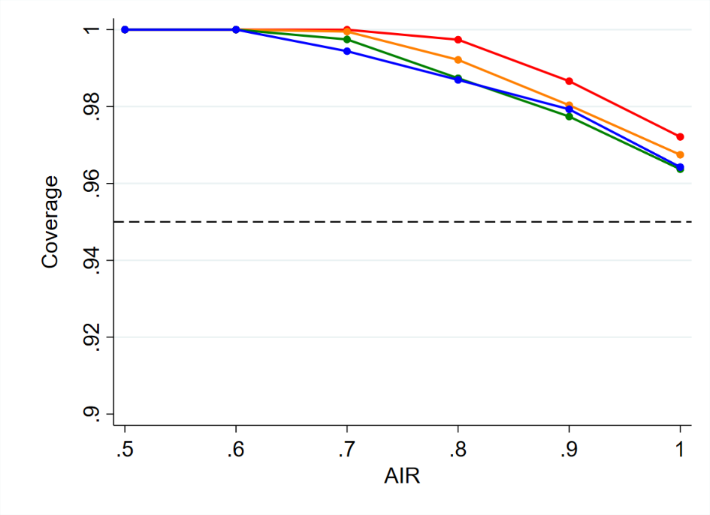

60 expected counterfactual events per arm
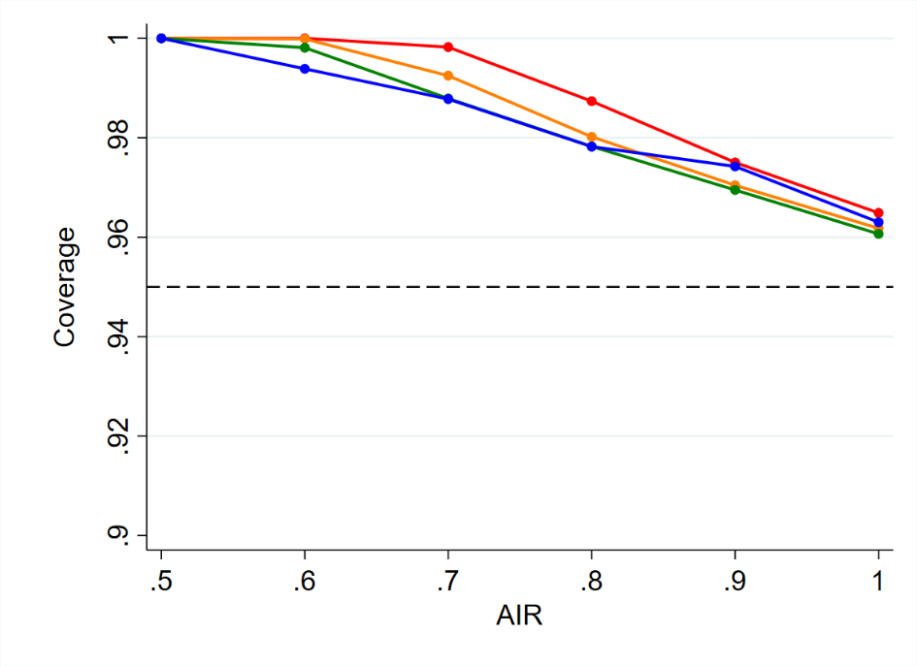

80 expected counterfactual events per arm
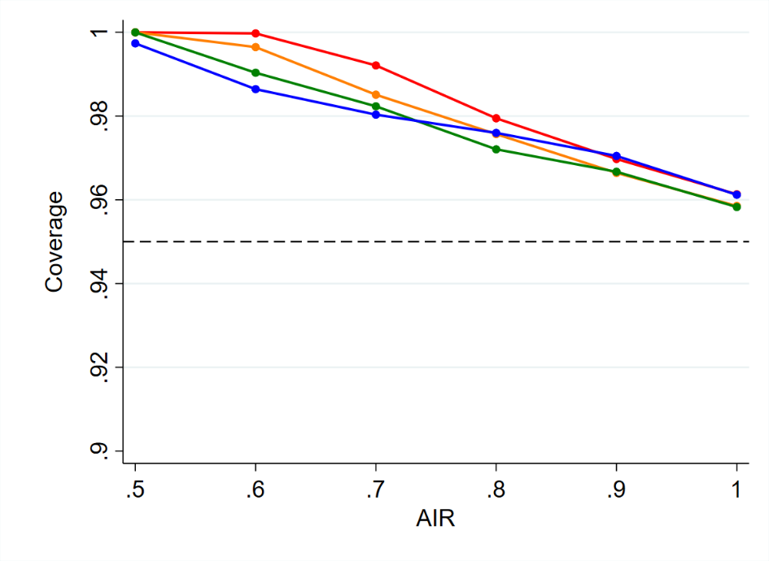

100 expected counterfactual events per arm 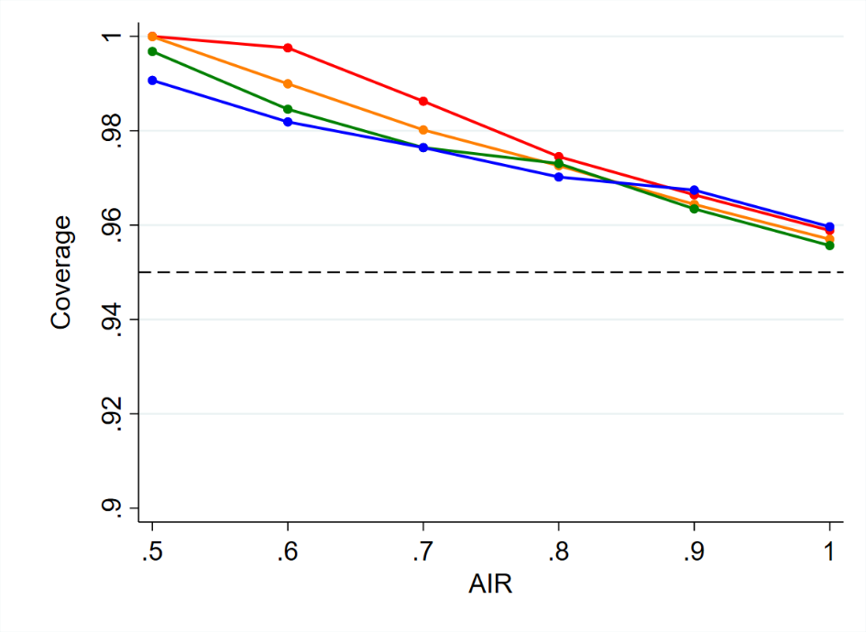
4. Coverage probabilities for likelihood-based confidence limits with 40 expected counterfactual events per arm

Upper 95% confidence limit (nominal coverage 0.95)
Effectiveness of control regimen(Θ_{C}) | AIR (Ψ)
 | 0.5 | 0.6 | 0.7 | 0.8 | 0.9 | 1.0
0.6 | 0.9661 | 0.9539 | 0.9502 | 0.9459 | 0.9521 | 0.9502
0.7 | 0.9562 | 0.9503 | 0.9493 | 0.9484 | 0.9520 | 0.9511
0.8 | 0.9513 | 0.9490 | 0.9548 | 0.9539 | 0.9516 | 0.9518
0.9 | 0.9485 | 0.9495 | 0.9586 | 0.9548 | 0.9515 | 0.9615

Lower 2.5% confidence limit (nominal coverage 0.975)
Effectiveness of control regimen(Θ_{C}) | AIR (Ψ)
 | 0.5 | 0.6 | 0.7 | 0.8 | 0.9 | 1.0
0.6 | 0.9749 | 0.9757 | 0.9761 | 0.9755 | 0.9764 | 0.9757
0.7 | 0.9770 | 0.9762 | 0.9759 | 0.9759 | 0.9755 | 0.9770
0.8 | 0.9771 | 0.9760 | 0.9763 | 0.9764 | 0.9757 | 0.9770
0.9 | 0.9759 | 0.9758 | 0.9780 | 0.9758 | 0.9754 | 0.9812

Upper 97.5% confidence limit
Effectiveness of control regimen(Θ_{C}) | AIR (Ψ)
 | 0.5 | 0.6 | 0.7 | 0.8 | 0.9 | 1.0
0.6 | 0.9999 | 0.9977 | 0.9882 | 0.9792 | 0.9768 | 0.9758
0.7 | 0.9991 | 0.9912 | 0.9779 | 0.9758 | 0.9758 | 0.9770
0.8 | 0.9945 | 0.9813 | 0.9734 | 0.9755 | 0.9763 | 0.9770
0.9 | 0.9844 | 0.9782 | 0.9743 | 0.9767 | 0.9792 | 0.9812

5. Cumulative distribution function (CDF) of the lower 5% confidence limit (true AIR=1, 40 expected counterfactual events per arm)

Delta method, blue line; profile-likelihood method, red line.
Vertical line represents the true AIR (intersection with CDF corresponds to coverage.
Note that the curves are non-smooth because of the discrete sample space.

Control regimen efficacy=0.6
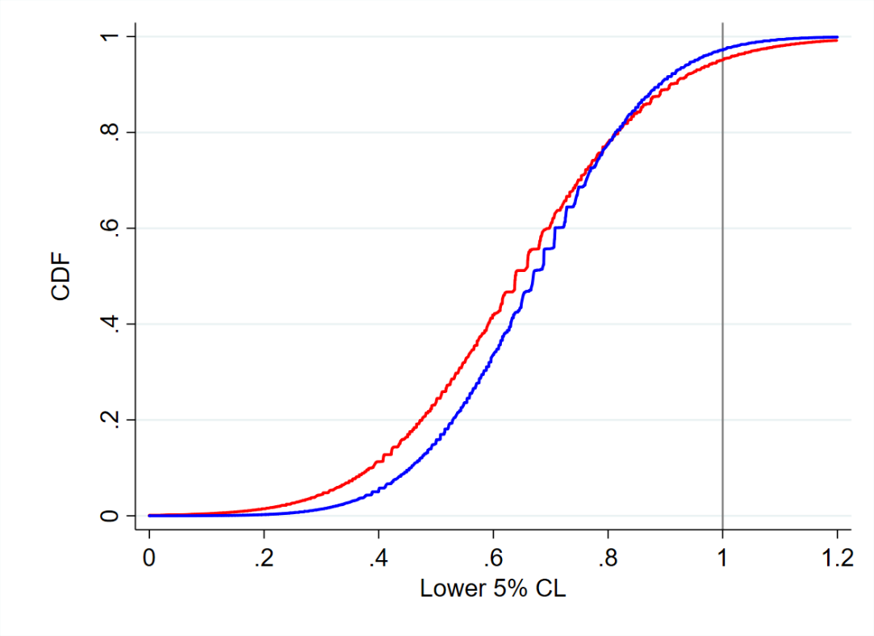

Control regimen efficacy=0.7
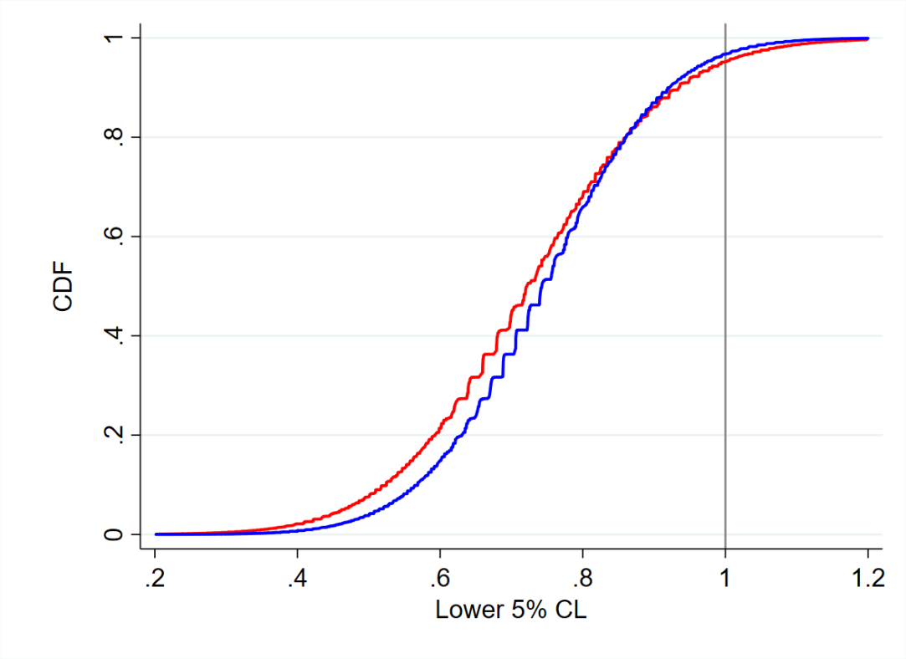

Control regimen efficacy=0.8
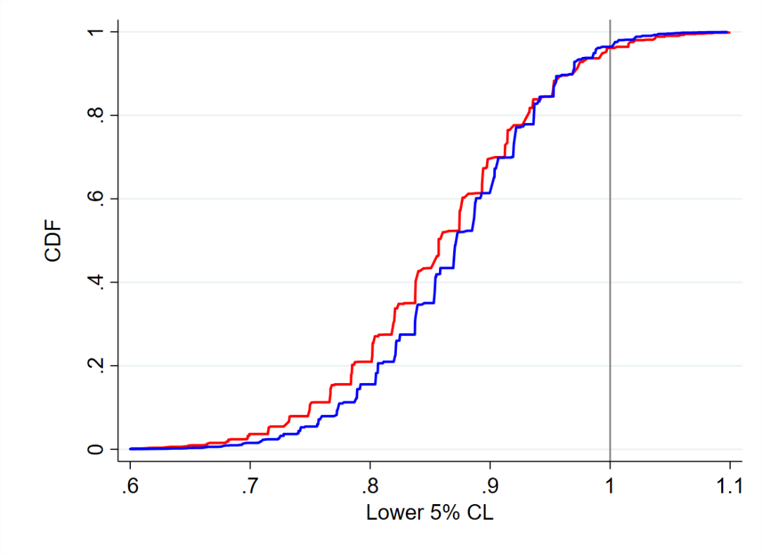

Control regimen efficacy=0.9

